**Software Development Pool Club Website**

Brief: I will be making a website for a pool club my client will be the pool club members and the website will be made to show what the pool is club is about. It will also include a about page which will allow the user to sign up to it.

**Research**

**Similar Sites**

<http://masse.co.nz/>

<http://www.lakecoleridgenz.info/billiardsclub.html>

<https://www.kaiapoiclub.co.nz/sections/billiards-snooker>

<http://www.daviebilliardclub.com/>

<https://vipbilliards.ca/>

**Key features for club sites**

* Banner relating to pool
* Navigation bar relating to theme that leads to the website pages
* Images relating to pool club.
* About Page Describing what our club is about.
* Form for user to sign up
* Colour scheme that relates to pool.
* Theme that relates to pool.
* Clean easily readable font.
* Working Links
* Working Images
* Sign Up Page
* Footer with links.
* Slideshow of Images

**Special client requirements**

The special client requirements for this website will be that the website needs to be simple and accessible so that anyone can see what our club is about. The signup form also needs to be straightforward and simple so anyone can sign up. The client wants the website to have a green and black theme.

**Current Website Trends**

The current website trends that apply to this website are using vintage fonts which will fit the theme of pool very well. These fonts include. The Cooper Black typeface font and vesterbro black. The CSS Grids design trend can also apply to this website, CSS grids will make the website easier to design by giving me the ability to put content in rows and columns. Another design trend large text can be used in this website.

**Specifications:**

* Slideshow
* Navbar
* Images
* Banner
* Footer
* CSS Grids Layout
* Sign up form.
* Green and Black Colours
* Homepage
* About Page
* Sign Up Page

**High Fidelity Wireframe 1 Home Page**

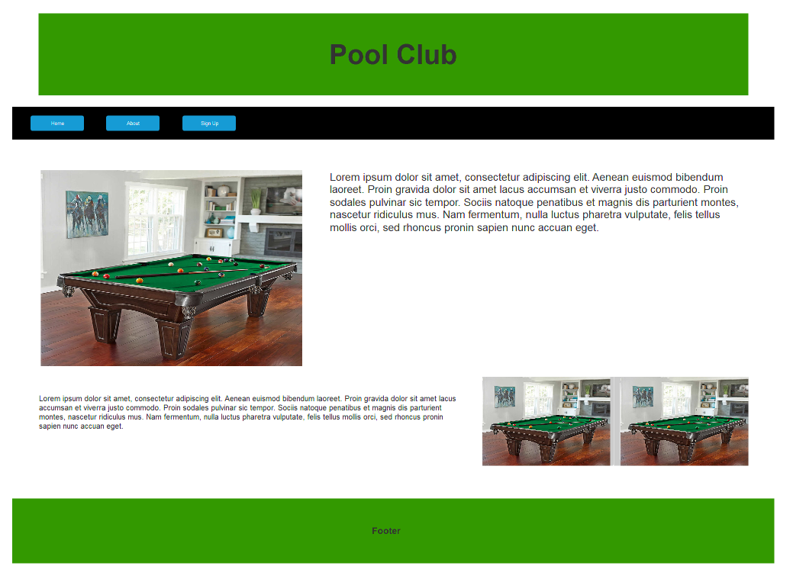

**High Fidelity Wireframe 2 Homepage**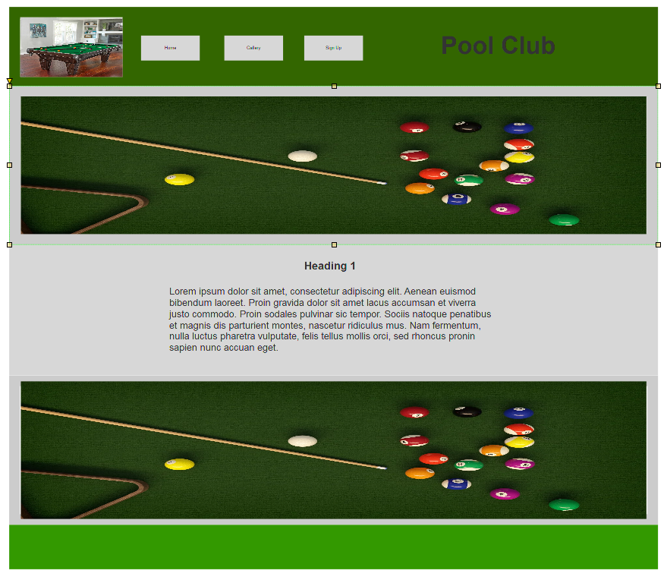

**High Fidelity Wireframe 3 Home Page**

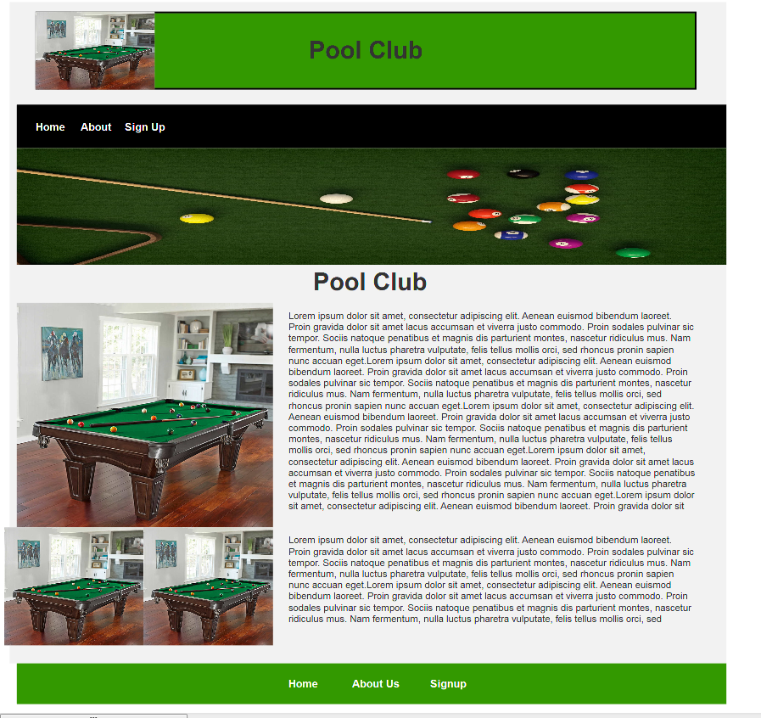

**Product Backlog**

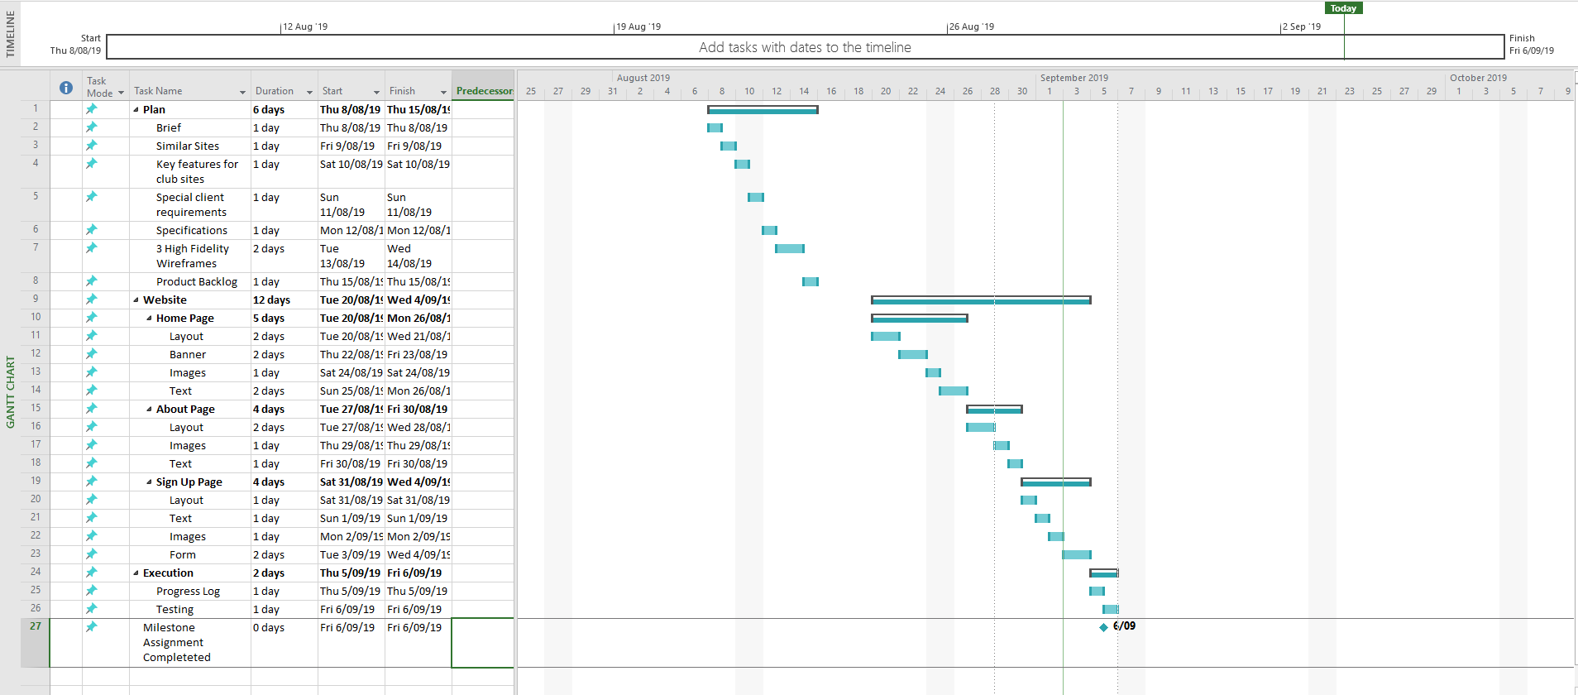

**Progress Log**

**Plan**

|  |  |
| --- | --- |
| **Task** | **Issues** |
| Brief | No Issues |
| Similar Sites | Had trouble finding similar sites from New Zealand |
| Key Features for Website | No Issues |
| Special Client Requirements | No Issues |
| Specifications | Had trouble thinking up enough specifications |
| 3 High Fidelity Wireframes | Did Wireframes for pages other than the homepage. Which was unneeded work. |
| Product Backlog | Save was corrupted and i had to start a new microsoft project. |

**Website**

|  |  |
| --- | --- |
| **Task** | **Issues** |
| Home Page | Had trouble figuring out how to use css grids |
| About Page | No Issues |
| Sign Up Page | Had issues with form structure |

**Execution**

|  |  |
| --- | --- |
| **Task** | **Issues** |
| Progress Log | Had trouble finding a format |
| Testing | No Issues |

**Testing**

|  |  |  |  |  |  |  |  |
| --- | --- | --- | --- | --- | --- | --- | --- |
| Test Scenario | Test Case | Pre Condition | Test Steps | Test Data | Expected Results | Actual Result | Pass/Fail |
| Buttons take you to the correct page | Click button for homepage and other pages | Open index.html and run the website in a browser | Open index.html with a browser. Click on a button in the navbar. | Index.html | The button takes the user to the right webpage. | The button takes the user to the right webpage. | Pass |
| Images Appear on page | Open the page in a suitable browser and check images | Open index.html and run the website in a browser | Open index.html and checking if the images load correctly | Index.html and images | The images load and they are the correct images | The images load and they are the correct images | Pass |
| Can enter data into form. | Open the Sign Up page and enter data into form | Open index.html and run the website in a browser click on the sign up button on the navbar | Open Signup.html and  Check if you can type data into the form. | Signup.html and form | User can type and enter information into the form | User can type and enter information into the form | Pass |
| Submit button works correctly | Open the Signup Page and enter data into the form and submit it. | Open index.html and run the website in a browser click on the sign up button on the navbar and enter data into the form | Open Signup.html and  type data into the form then check if you can submit it. | Signup.html and form | User can use the submit button for the form. | User can use the submit button for the form. | Pass |
| Website formatted correctly | Compare the homepage to the high fidelity wireframe. | Open index.html with a suitable browser | Open index.html with a suitable browser | Index.html | The homepage is formatted the same as the high fidelity wireframe. | The homepage is formatted the same as the high fidelity wireframe | Pass |
| Slideshow slides through correct images | Open any website page and make sure the slideshow goes through the images | Open any of the html files in a browser | Open one of the website html files in a suitable browser and check if the slideshow is going through the correct slides | Index.html  About.html  signup.html | The slideshow slides through the correct slides | The slideshow slides through the correct slides | Pass |
| Footer links work correctly | Open the website in any page and make sure the footer links work correctly | Open any of the html files in a browser | Open one of the website html files in a suitable browser and check if the footer links take you to the correct page | Index.html  About.html  signup.html | The footer links work correctly | The footer links work correctly | Pass |
| Slideshow selection buttons work correctly | Open the website in any page and make sure the slideshow selection buttons work correctly | Open any of the html files in a browser | Open one of the website html files in a suitable browser and check if the slideshow selection buttons work correctly | Index.html  About.html  signup.html | The slideshow selection buttons work correctly | The slideshow selection buttons work correctly | Pass |